Data Source 2: Excel spreadsheet

First Excel File is loaded

1. Check Null Fields
2. Check if it has proper data types
3. Check Foreign Key References

**Filter Rows**

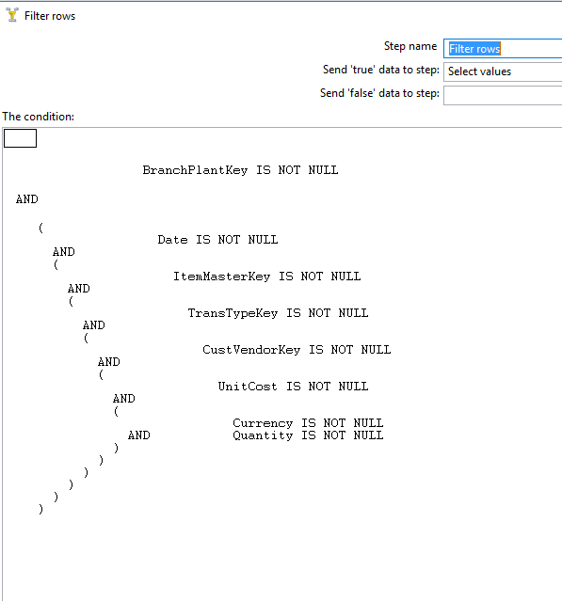

**DataValidator**

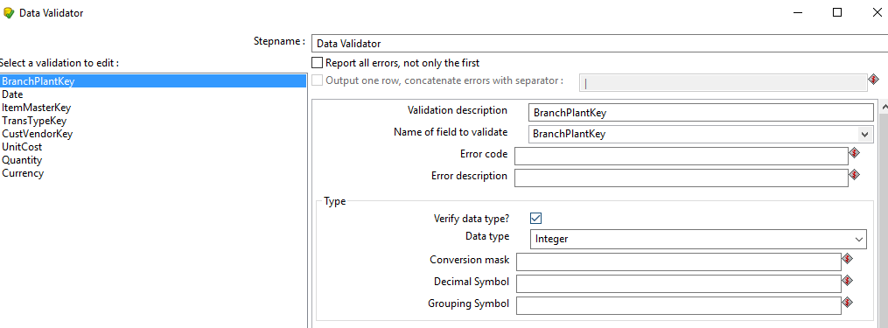

**Transformation**

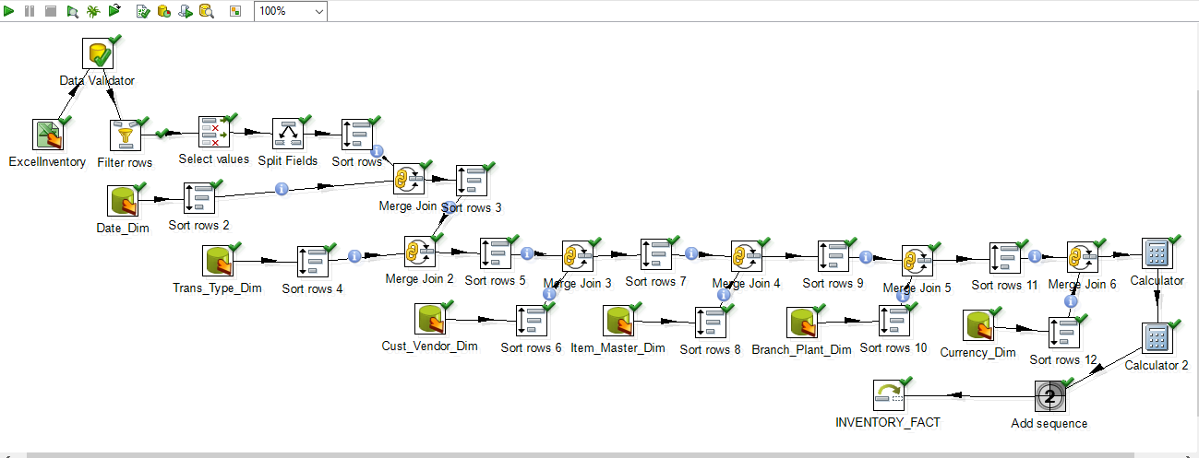

**After running the above, Transformation,10 rows were inserted.**

